# Process to install Github Desktop and get code from the 2019 version

1. Install the Github desktop app on your computer at <https://desktop.github.com/> . Make sure you have a Github account. This is optional, but you can download Github Desktop, and it makes the process of seeing edits and pushing code to Github a lot easier IMHO.
2. Go to VS Code, the gear symbol at the bottom, Settings then go to Extensions in the User interface (in settings), Git, and go down to Default Clone Directory type in C:\Users\Public\frc2019\workspace. (the reason for Public is because everyone has Public as a User)

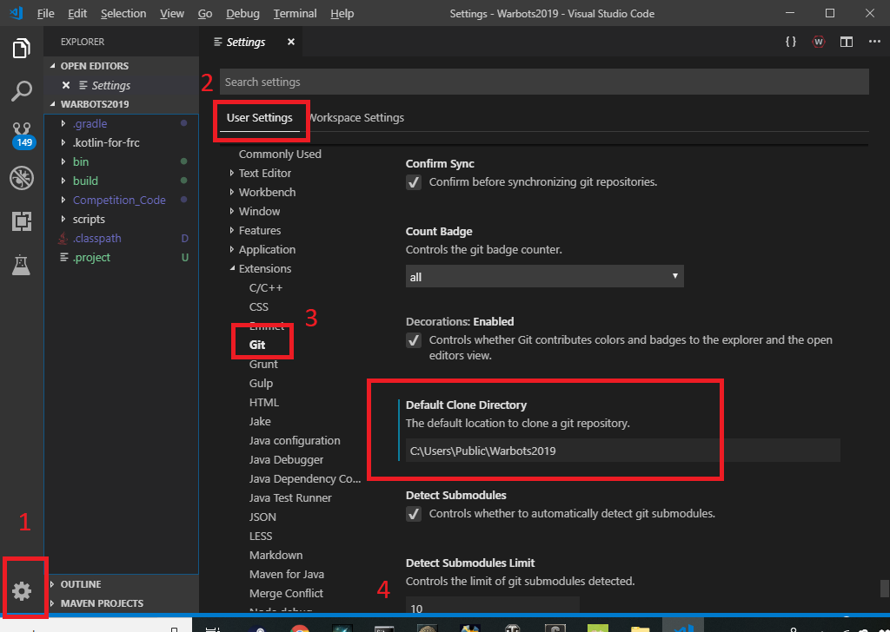

# How To:

## Get code from Repo (Repository) [first time]:

1. In VS Code, press Ctrl+Shift+P or go to View, Command Palette, and type in “git clone”

## Get changes from other people from REPO:

1. In VS Code, press Ctrl+Shift+P or go to View, Command Palette, and type in “git pull”

## Send changes to Repo

1. In VS Code, press Ctrl+Shift+P or go to View, Command Palette
2. type in “git commit -a -m “message””, the “message” part of “git commit -a -m “message”” allows you to attach a message to your changes. PLEASE ENTER REASONABLE AND INFORMATIVE MESSAGES, so people know why you made the change;
3. “git push”

Add a new file to Repo

Go to Github, the Repository, and click “Create new file” near the “Clone or download” at https://github.com/FRC-Team-620/Warbots2019

Delete a file from Repo

Go to Github, click on a file (.classpath for example) and click on the garbage can.